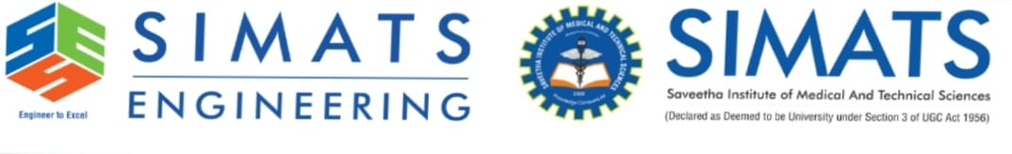
COMPILER DESIGN-CSA1402
CO1_AT2 ERROR ANALYSIS
NAME: N.SANDIYANITTIANANDAM
REGNO:192571029

Problem 1:
The following program is intended to perform simple arithmetic operations, function calls, array access, and looping constructs. However, the code contains multiple errors introduced at different phases of compilation, including lexical, syntax, semantic, logical, and runtime errors.
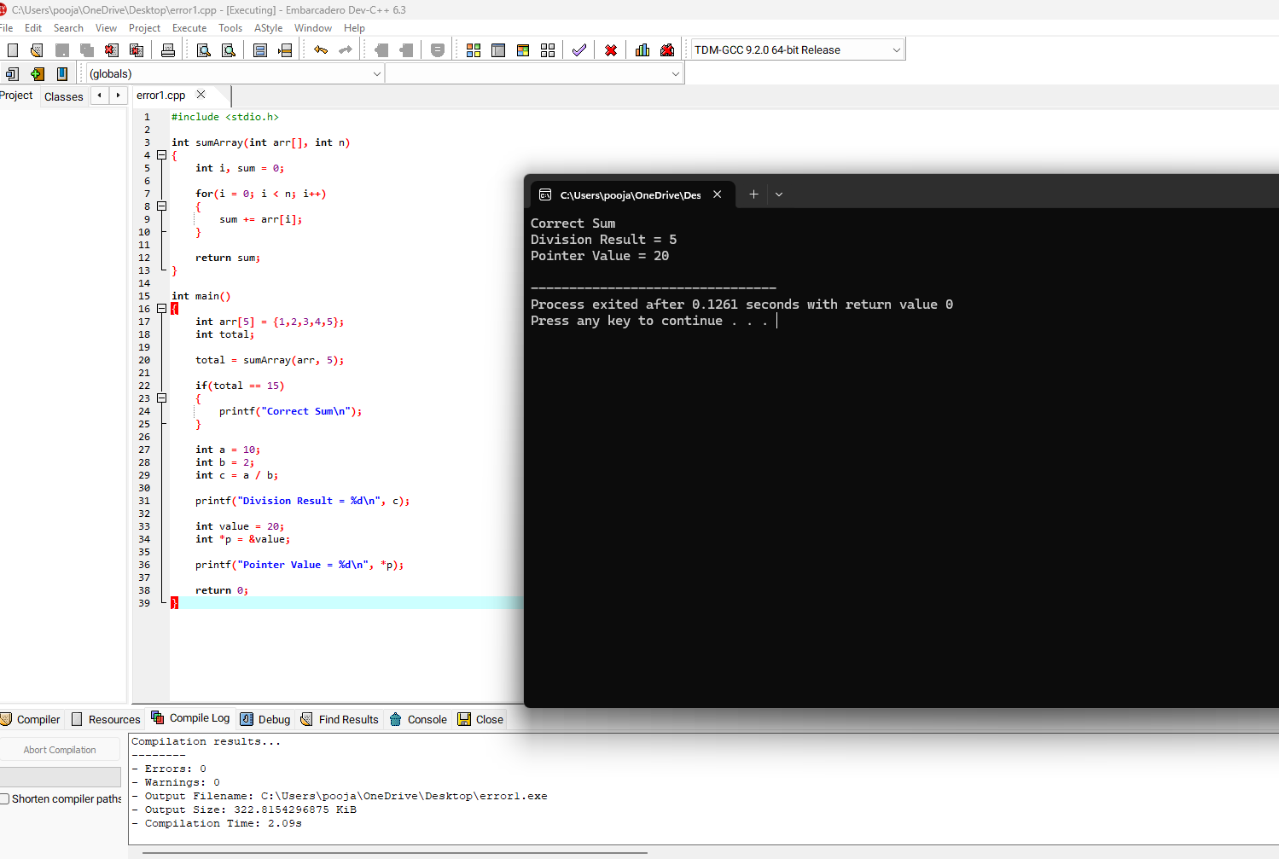
Problem 2:
The following C program contains multiple lexical errors introduced intentionally. These errors occur due to invalid tokens, incorrect identifiers, malformed constants, and illegal symbols, which are typically detected during the lexical analysis phase of a compiler.Carefully examine the program and answer the questions given below.
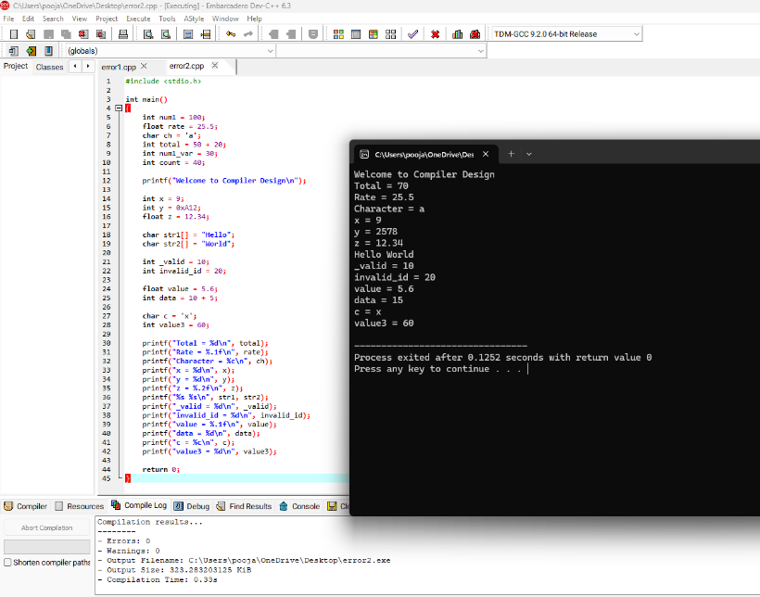

Problem 3:
The following C program is designed to perform arithmetic operations, function calls, conditional checks, pointer usage, and looping. However, the program contains multiple errors distributed across different phases of a compiler, including:
- Lexical Errors
- Syntax Errors
- Semantic Errors
- Intermediate Code Generation Issues (logic/precedence)
- Code Optimization Issues (redundancy/inefficiency)
- Runtime / Target Code Errors
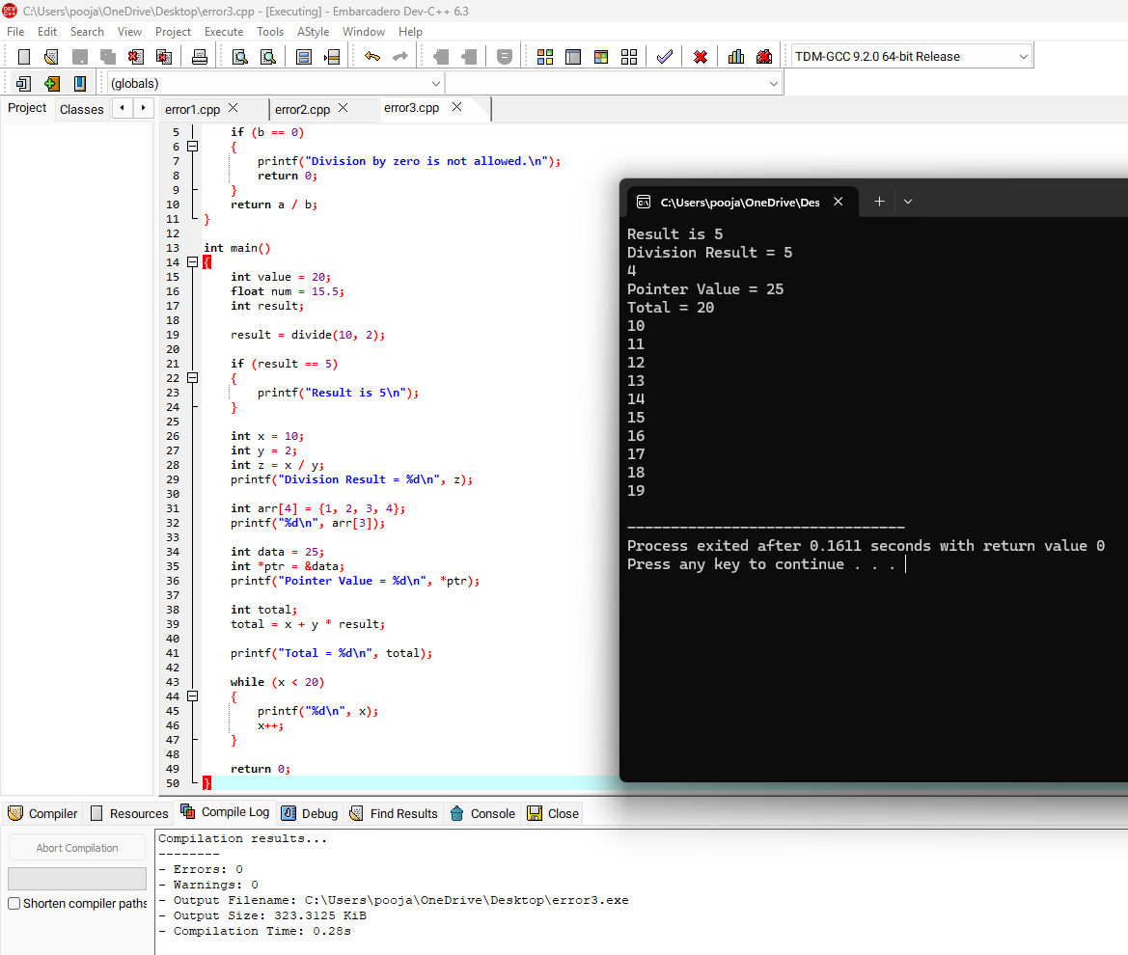

GITHUB:
